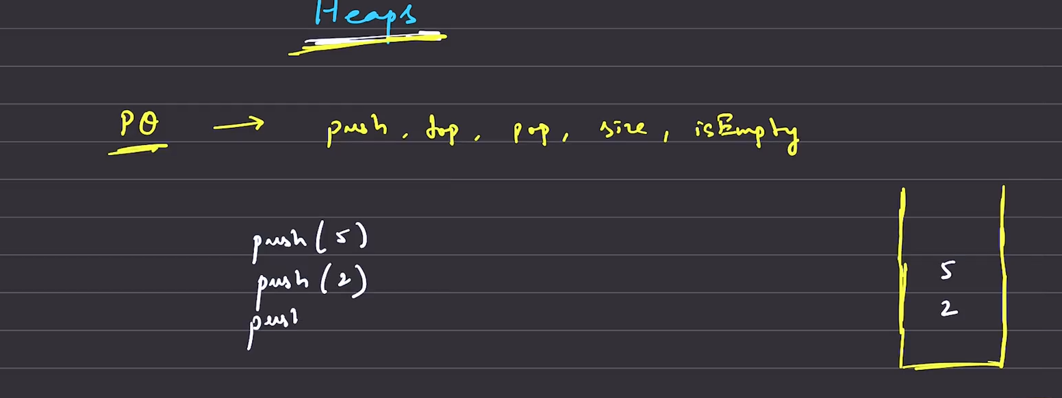
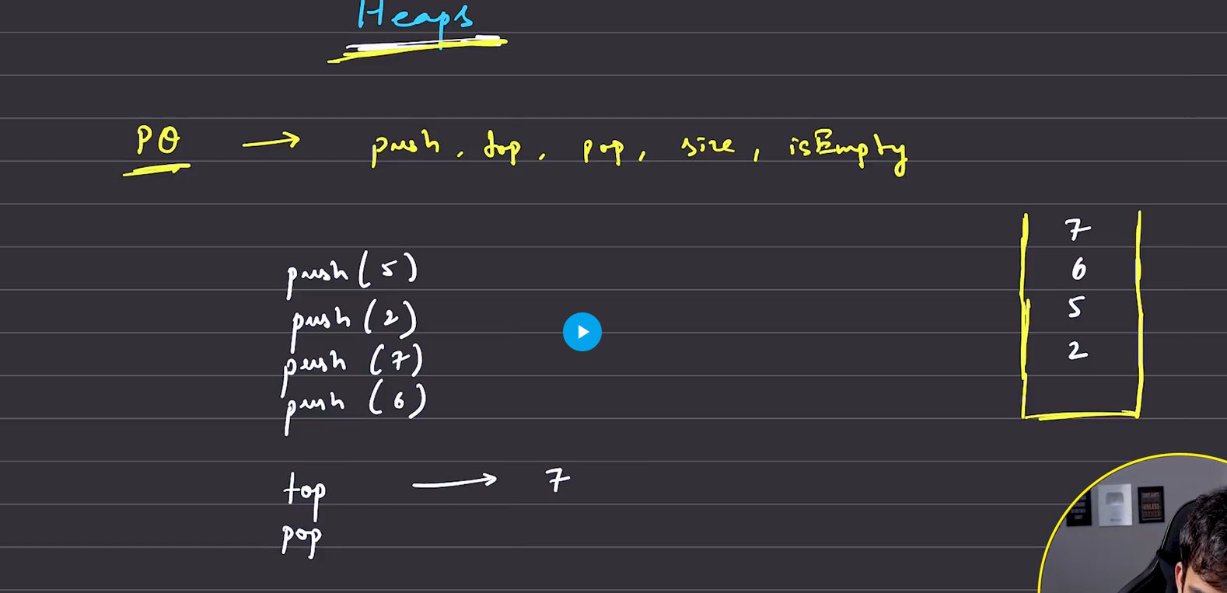
When pop is called then the greatest element is deleted from the PQ.
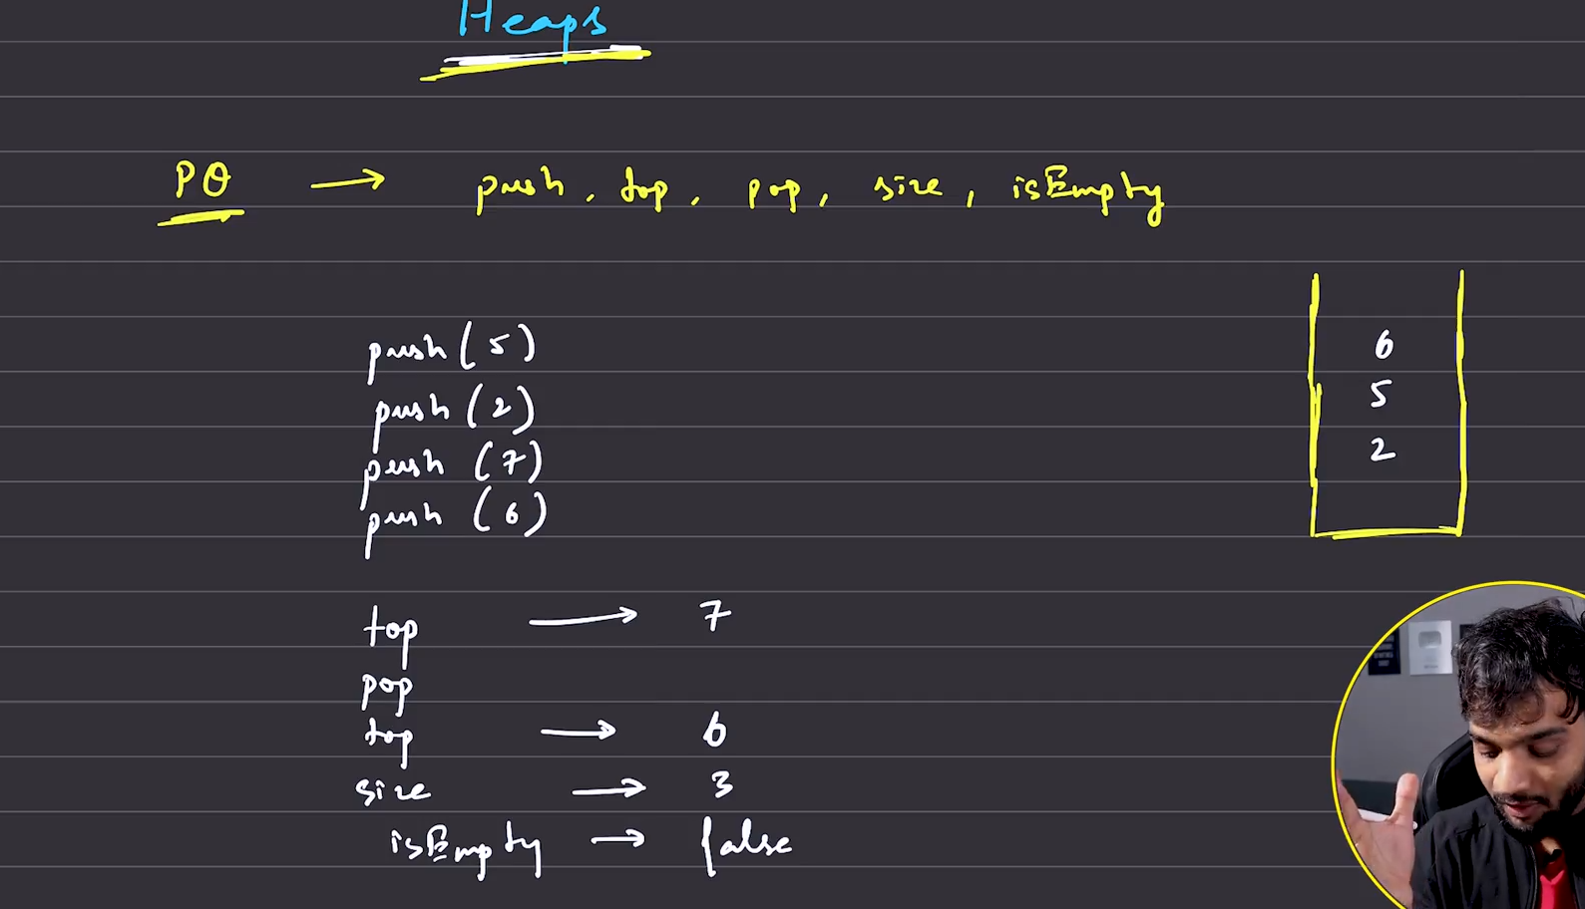
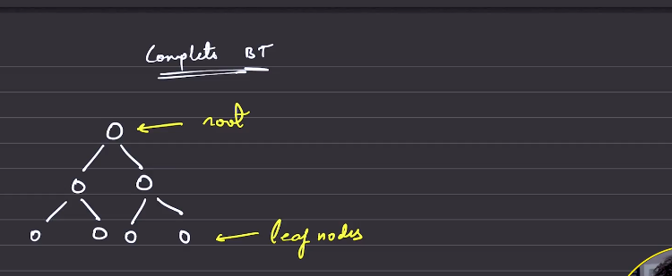
The above is complete binary tree
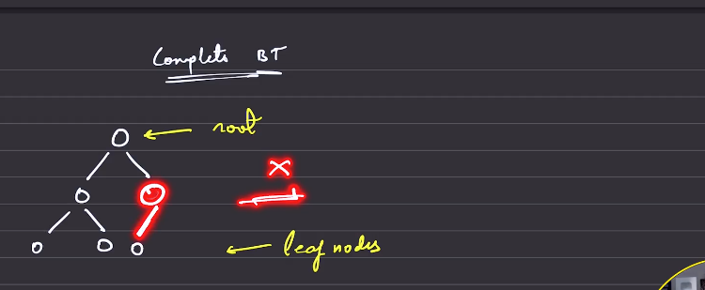
This is not complete biary tree
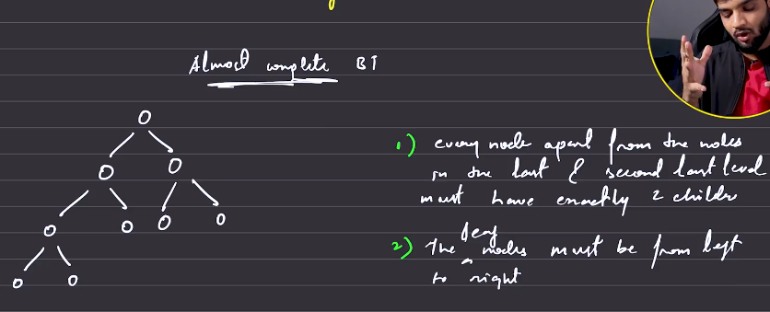
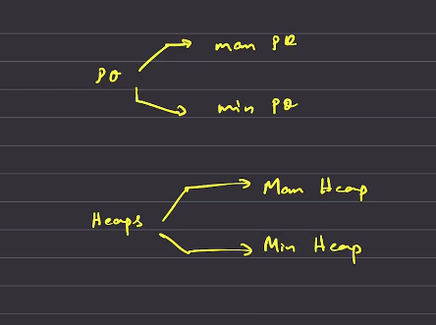
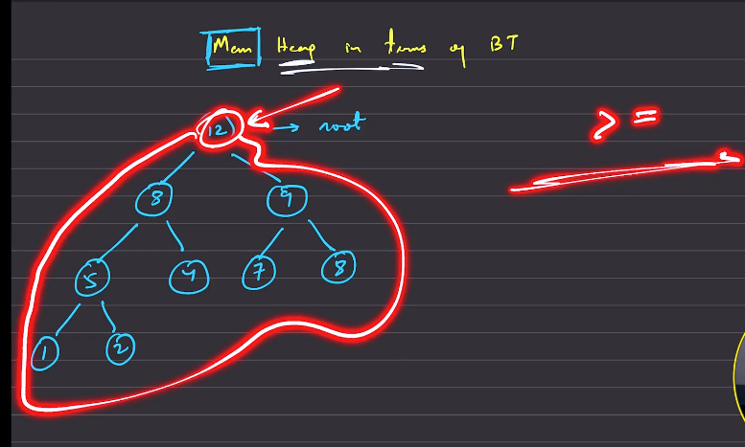
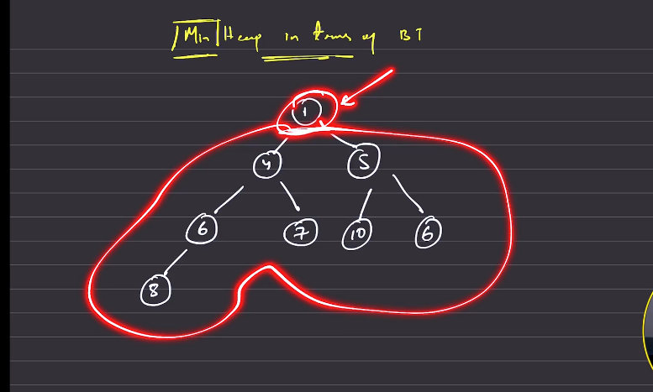
How do we store this in an array ?
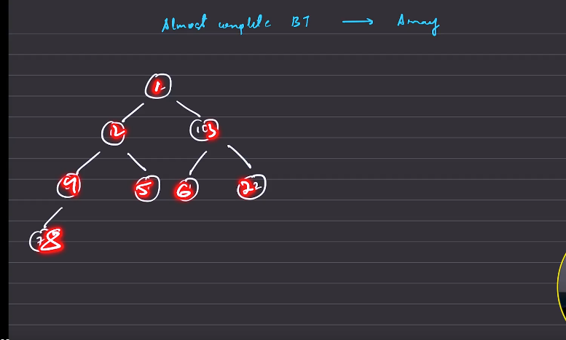
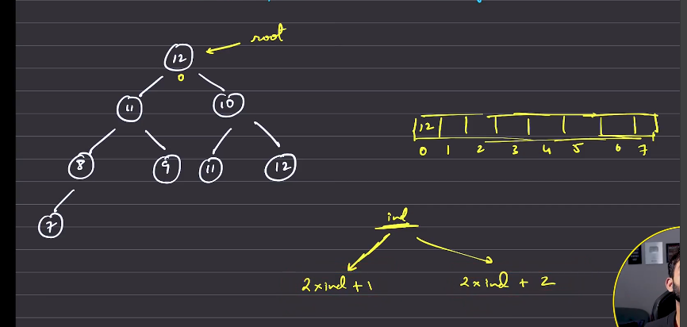
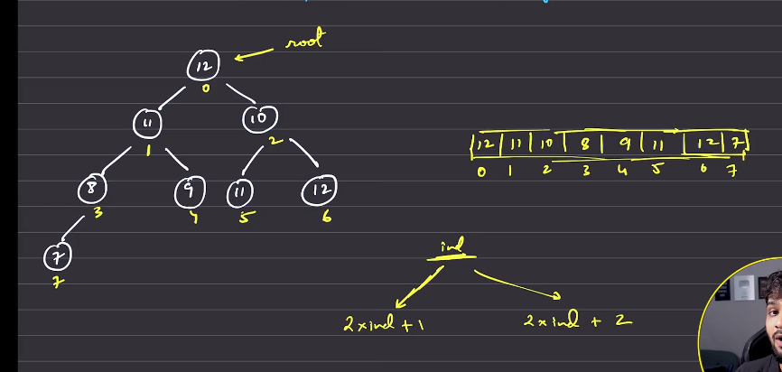
Just go throguh document of the tuf to know about it in detail

Heapify: Insert a node at the leaf and adjust upwards
We need max heap

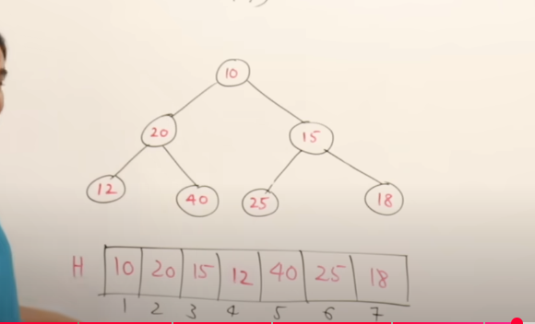
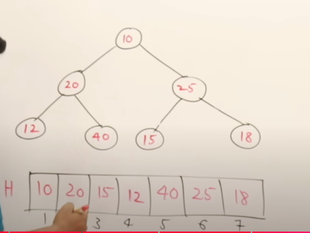
Now 24 will go up and 15 will come down
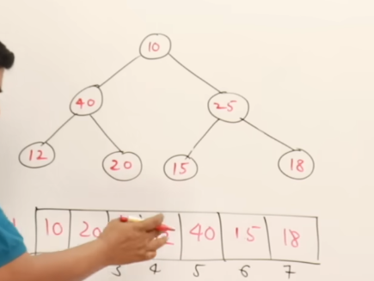
Now 40 has gone up and 20 came down
Compare with the children of 10 , whichever is grater that will be replaced
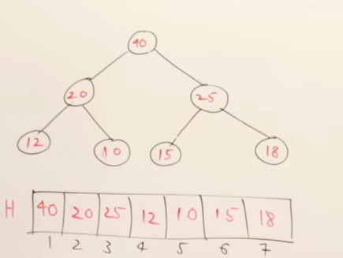
This procedure is called heapify
Time taken to heapify O(n) and
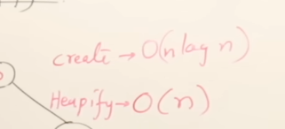

Priority Queue:
The inserted and deleted will have priority in it, when deleted that will endup in deleting the highest priority, here the number itself is a priority
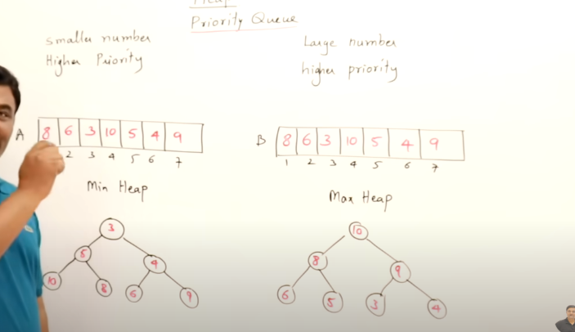
Implmenting the PQ using the array, will take the O(logn ), but implementing it using the heap will take the time O(logn) time for insertion and deletion. Hence using the normal array will not help

Check if the given heap is minimum or not?

Brute: Standing at the peak, check whether all the nodes that are towards the left of the parent node is smaller , check for all the nodes that are right of the node is smaller than the paent or not, this shall be done for all the nodes.

Optimisation:
All the leaf nodes are following the property, it is samller than all the parent nodes, so start checking for the non leaf nodes, that vary from 0 to (n/2)-1

Start checking – either from 0 to n-1 or from n-1 to 0. For each and every parent the chilld should follow the property of the the problem function.
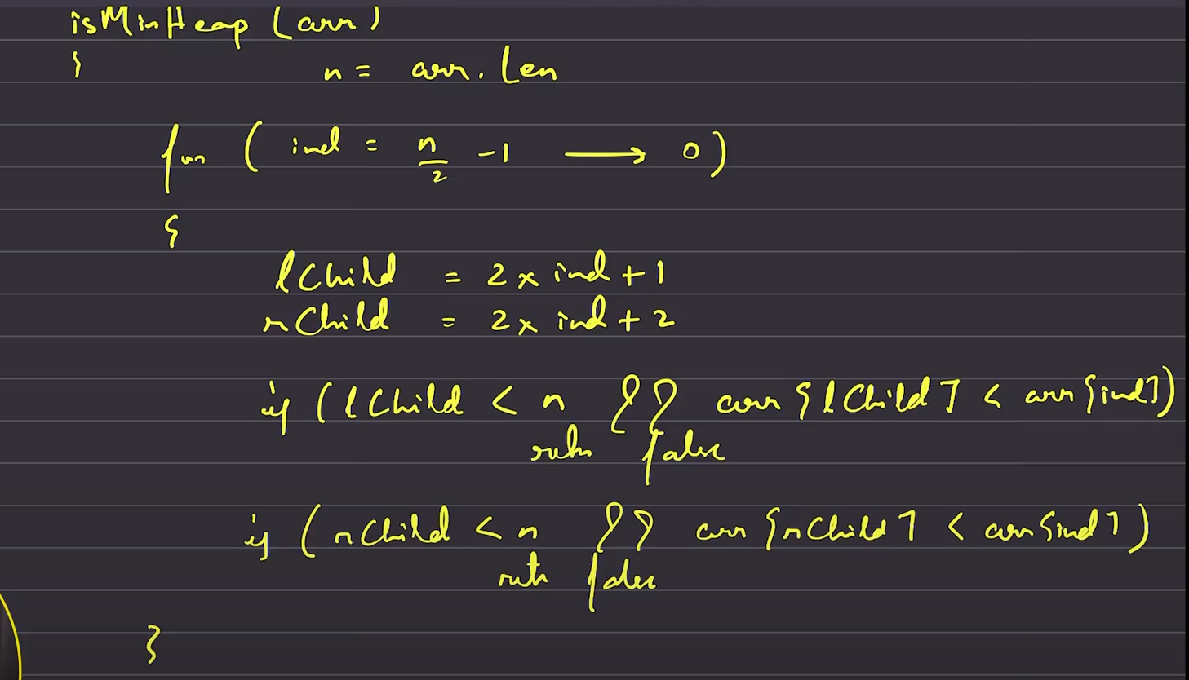
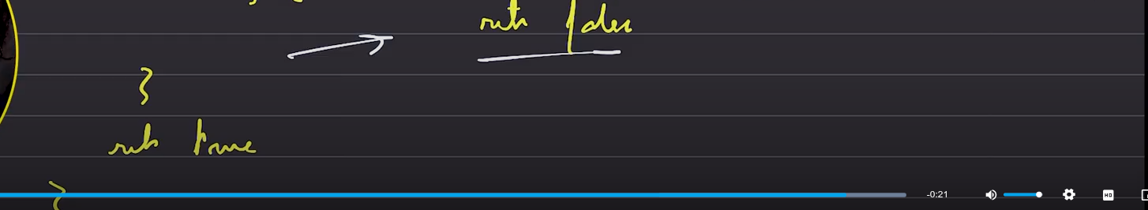

Convert from given minimum heap to maximum heap
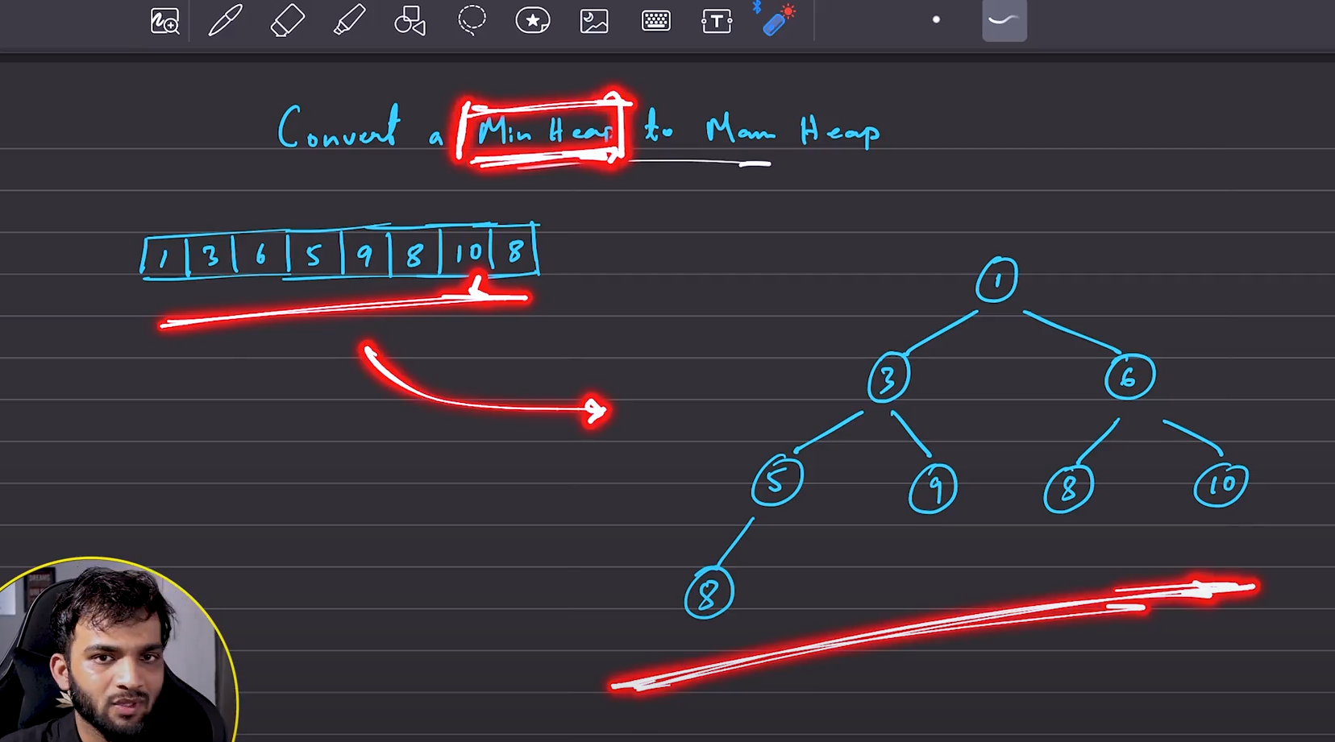
Consider the given array as random array. Then start heapifying the given array. The cdildnodes are aleady following the property, only the non child nodes are not properly heapified .

Start heapifying it from (n/2)-1 till 0, if the left child is present and the right child is presen then we focus on hecking which is largest among all, if the child found to be lnot folowing th prieprty with the parent then we are gong to swap it.

K-th Largest element in an array
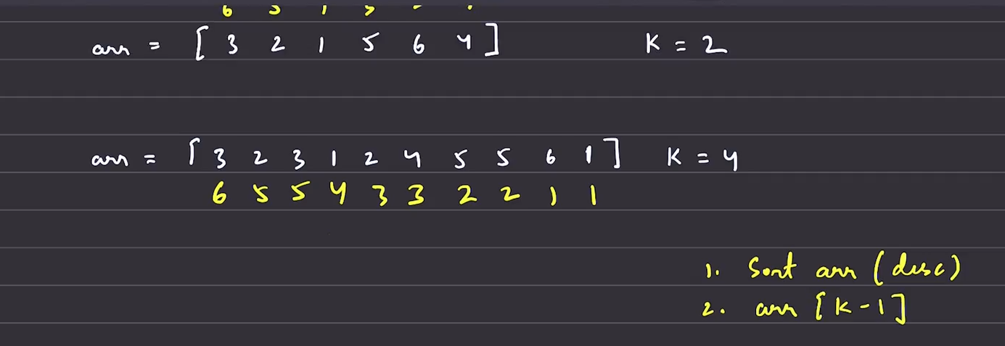
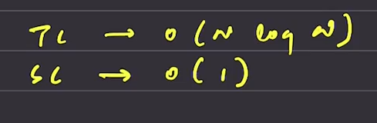
Better:

Here we need to deal with only the k elements which must be in sorted fashion, anything that comes after that, there i no need to give any attention to it. 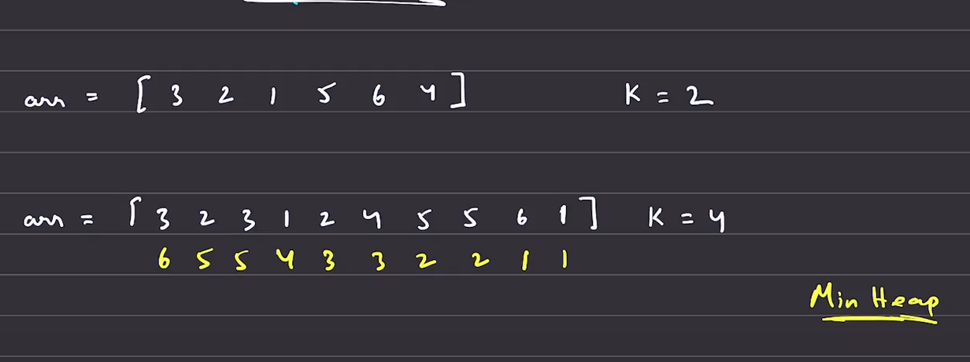
We try to utilise the minheap in this case, hence we are going to use the prority queue.
- Put k elements into the priority queue, let the size of pq shall be k.
- Start pushing the k+1th element till the nth element into the PQ, finnaly the one which is there in top of min PQ, that is the kth largest in the whole sorted array.

Since the dynamic implementations of the PQ is only available , we are going to check the top element with the array element, if the top elememnt is found to be greater than the array traversing element then the element is not inserted to the PQ, else it is insertd.
Top<arr[i]-> remove the top elemnt then insert.
After treversing the array, return the top element.

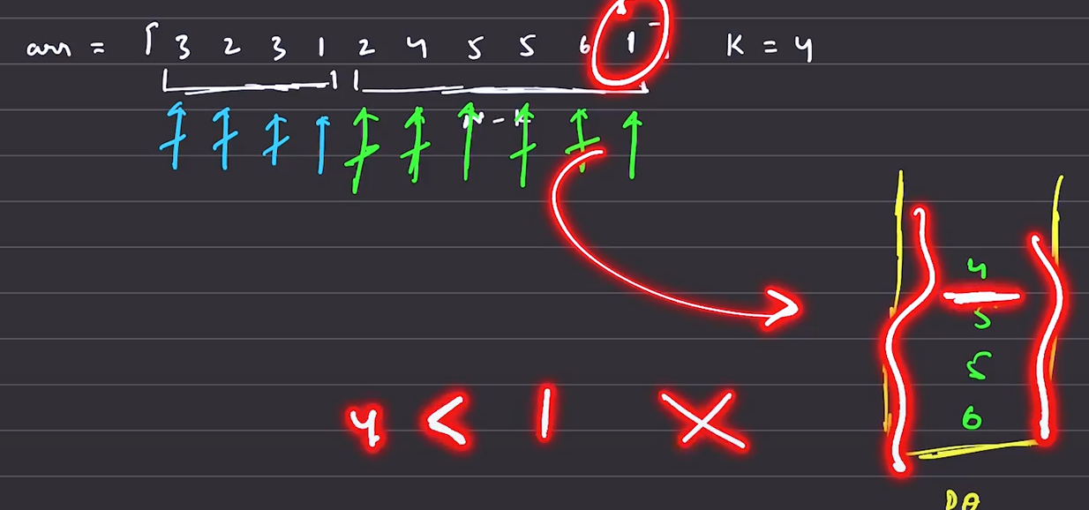

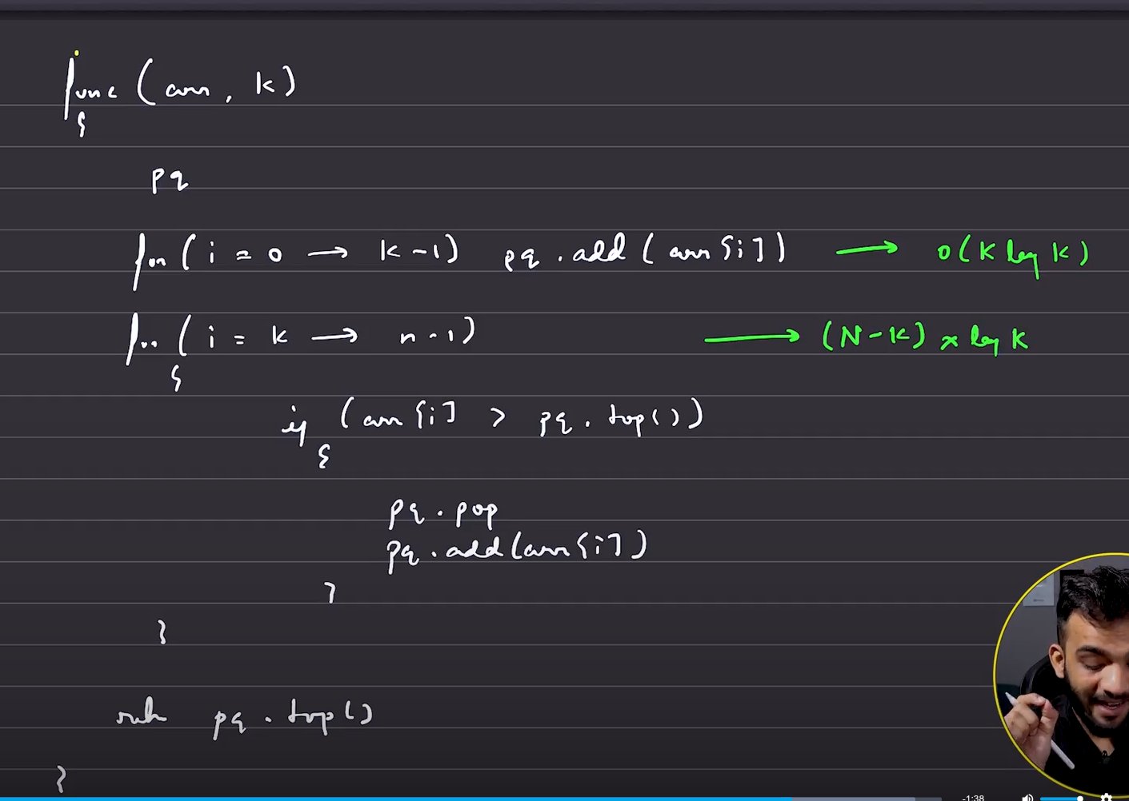
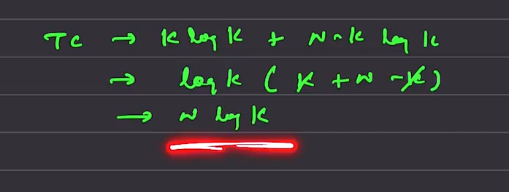
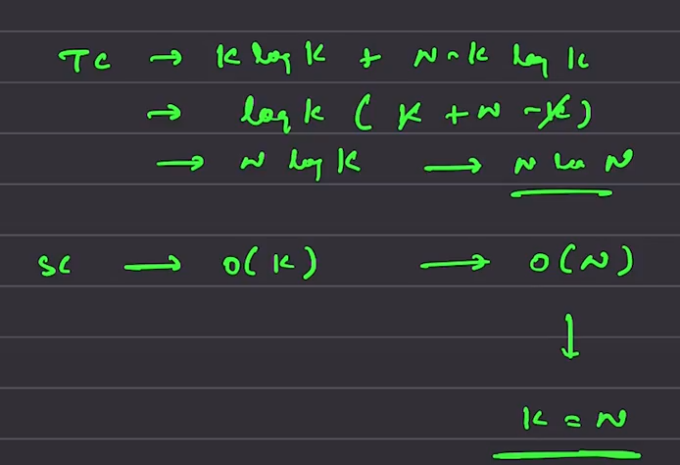
Optimal solution

O(N) – quick select and partition is the name of the algorithm.
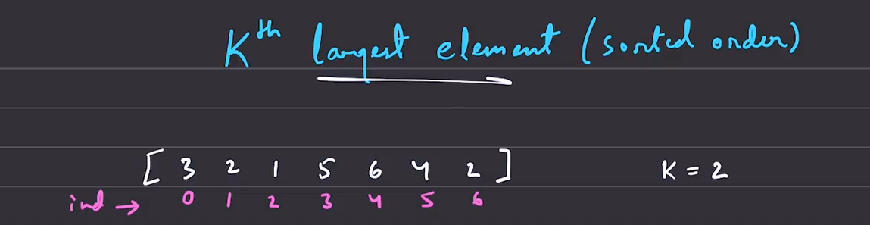
This can be implemented in O(n) way .
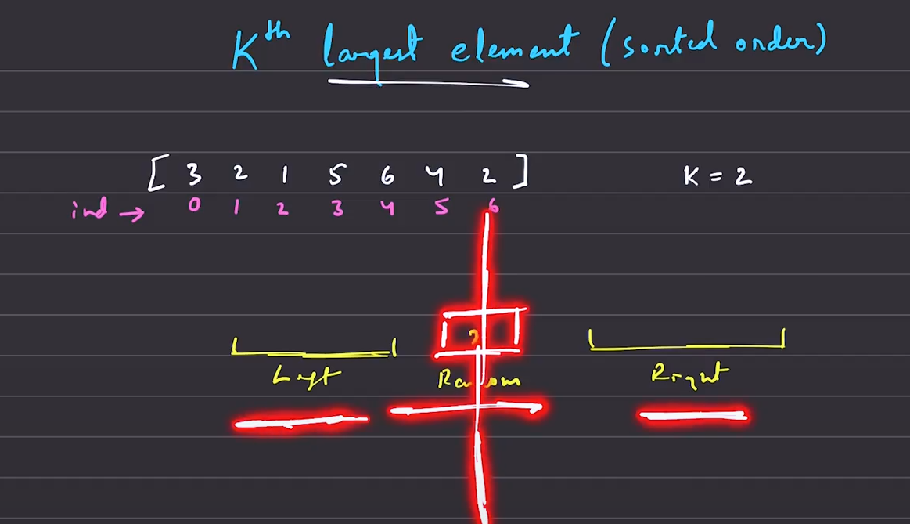
For the given array we need to pick up the second largest element, but that is not possible directly, so we are going to chose random point
The left ones are greater than and the right ones are smaller than 2. But the order in which the array elements is seen, or either part is not sorted by default.
Hence the first k largest is seen on the left and the last some elements seen are largest

Quickly select a point and based on that select
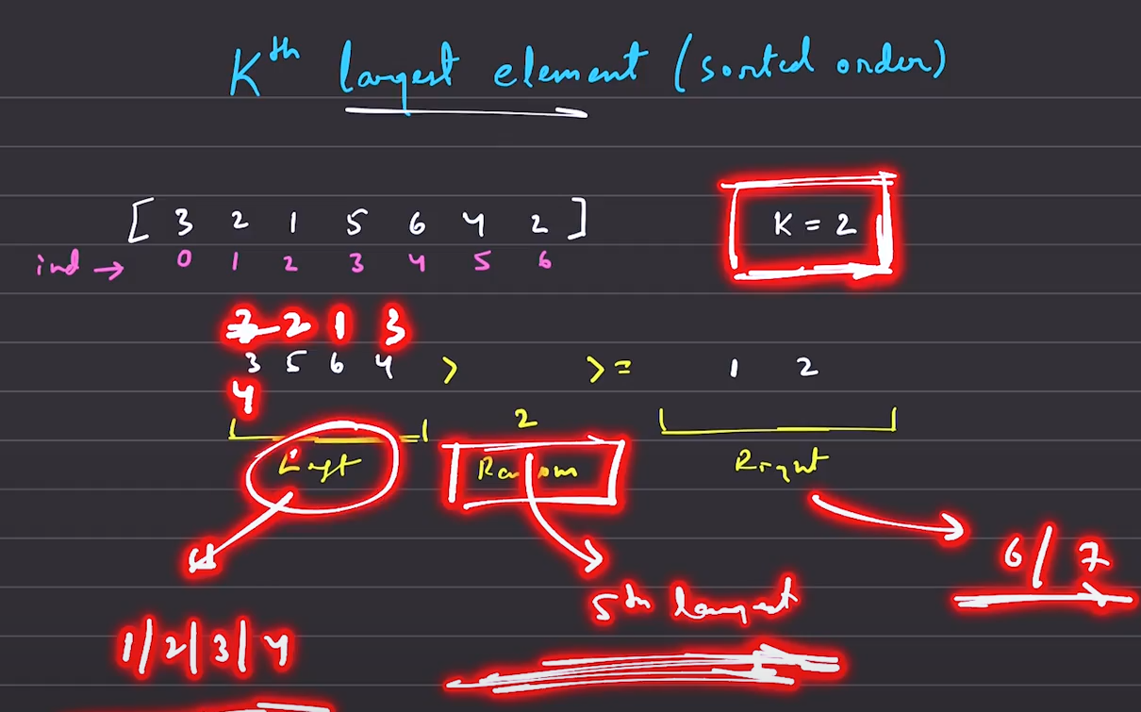
From this we got to know that 5 largest is there on the left side, based on the number of elenets that will be falliing into that place.
Hence there is no need to search in the right part of the array
Suppose if the k =6, then we were eliminating the points that were on the right of the array .

